10 Capstone projects

1. Autonomous Research Assistant An AI agent that browses the web, reads papers, synthesizes findings, and generates a structured research report — with citations — on any topic, using tool-calling and RAG pipelines.
2. Multi-Agent Software Engineering System A team of specialized agents (planner, coder, reviewer, tester) that collaboratively build, debug, and deploy a working application from a natural language specification.
3. AI-Powered Personal Finance Manager An agent that connects to bank APIs, categorizes transactions, detects anomalies, forecasts budgets, and proactively alerts users with actionable recommendations.
4. Autonomous Clinical Decision Support Agent A deep learning system trained on medical records and imaging data that assists doctors by suggesting diagnoses, flagging risks, and summarizing patient history — with explainability layers.
5. Self-Improving Code Generation Agent An agent that writes code, runs it in a sandbox, observes errors, reflects on failures, and iteratively rewrites until tests pass — implementing a full ReAct / reflection loop.
6. Agentic E-Commerce Operations Bot An end-to-end agent managing an online store: monitoring inventory, auto-negotiating with suppliers via email, adjusting pricing based on competitor scraping, and handling customer queries.
7. Deep RL Agent for Adaptive Game Playing A reinforcement learning agent trained via self-play and curriculum learning to master a complex game (e.g., a custom RTS or puzzle environment) and adapt its strategy to new opponents.
8. Multimodal Document Intelligence Agent An agent that ingests PDFs, images, spreadsheets, and contracts — extracts structured data using vision + language models — and answers complex cross-document questions autonomously.
9. AI Safety & Red-Teaming Agent An agentic system that automatically probes other LLMs for jailbreaks, prompt injections, and bias — logs vulnerabilities, classifies severity, and generates mitigation reports.
10. Autonomous Urban Planning Simulator A deep learning + agent-based simulation where AI agents representing citizens, planners, and businesses interact in a city model — optimizing for traffic, emissions, and livability using reinforcement learning.

Each of these combines agentic orchestration (planning, tool use, memory, reflection) with deep learning components (transformers, RL, vision models), making them strong capstone candidates for graduate or advanced undergraduate programs. Want me to flesh out any of these with architecture diagrams, tech stacks, or implementation roadmaps?

--------
10. Here's a breakdown of the six layers:

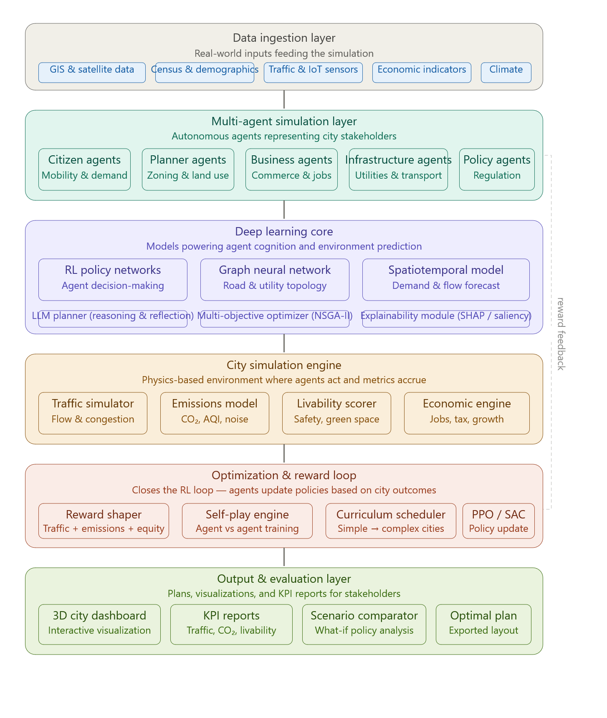
Data ingestion pulls from GIS maps, census records, IoT traffic sensors, economic data, and climate models to ground the simulation in reality.
Multi-agent layer is the heart of the system — five agent types (citizens, planners, businesses, infrastructure, policy) interact autonomously, each with goals that sometimes conflict (e.g. citizens want green space, businesses want density).
Deep learning core powers everything: RL policy networks for agent decision-making, a Graph Neural Network modeling road and utility topology, and a spatiotemporal model forecasting demand and flow. An LLM-based planner handles high-level reasoning and reflection.
City simulation engine runs the actual environment — traffic flow, emissions/AQI tracking, livability scoring, and an economic engine — measuring the real consequences of agent actions.
Optimization & reward loop closes the RL training cycle. Rewards are shaped across multiple objectives (traffic, emissions, equity), and curriculum learning gradually increases city complexity during training.
Output layer serves stakeholders: a 3D dashboard, KPI reports, a scenario comparator for what-if policy analysis, and exportable optimal layout plans.
Every node in the diagram is clickable to explore that component in depth. Want me to zoom into any specific layer or generate a data flow / sequence diagram for a particular subsystem?

